Welcome to Term 2
Welcome to Term 2! We hope you have all had a lovely half term and are feeling refreshed for another busy term. We hope that you find this newsletter a useful guide to the activities and learning opportunities that will take place during the upcoming term.

Our curriculum overview is available on our year page and you can find details of what we will be learning about in each subject below.
If you or anyone that you know have any skills linked to what we will be learning about this term and you would be willing and able to come in and share them with the children, please let your child’s class teacher know, as this can be a very enriching experience for the children and they absolutely love having visitors. We also welcome reading volunteers in to read with the children. Please let us know if you can help with this.
Please visit our year group web page to find copies of all communication sent home, homework, spellings, key information and dates, as well as a range of photos on your child’s class page.

We will be available on the playground at the end of the school day and can be contacted by email. Our contact details are below and can also be found on the school website, so please do get in contact if you need to at any point.
thughes@ashtongateprimary.org dmurphy@ashtongateprimary.org
mconsidine@ashtongateprimary.org
enisbet@ashtongateprimary.org sbrown@ashtongateprimary.org

Year

Term 2 Newsletter

Rising
High
Together

Dates for your diary and special events:
Mon 3rd November- INSET Day – school closed. First day of Term is Tues 4th Nov
Mon 10th and Wed 12th November - Upton Parents’ Eve
Monday 17th and Tuesday 18th November - Trip to courts
Wednesday 19th November – Trinity music trip.
Weds 10th December 2pm - Carol concert to Y5 parents

Friday 12th December 2pm - Carol concert to Y6 parents

Friday 12th December (morning) – Y5 Rockband performance to parents – timings TBC
Thurs 18th Dec – Upton Christmas Lunch
Fri 19th Dec – last day of term

English
In our English lessons this term, we will be reading The Last Wild by Piers Torday — an exciting and imaginative story about courage, friendship and the power of hope. The book follows a young boy named Kester who discovers he can communicate with animals and sets out on a thrilling adventure to save them.

Maths
In maths this term, we will be working on fractions. This will include finding fractions of amounts, equivalent fractions and adding and subtracting fractions. Pupils will also apply their understanding to real-life problems and develop strategies to explain their reasoning with confidence.

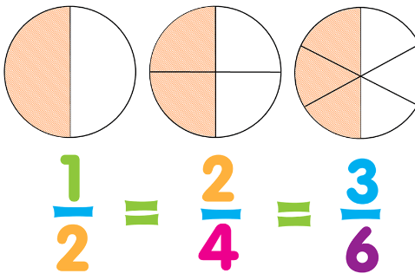
Add picture here
PSHE
In PSHE we will learn about respect, diversity and stereotyping.

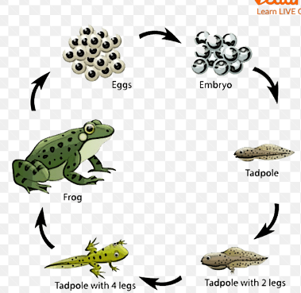
Science
This term we will be exploring how animals and humans change as they grow.
We will learn about learn about the digestive and circulatory systems and how to keep our bodies healthy.
Through hands-on investigations, we will discover how different animals adapt to survive.
This exciting topic builds curiosity and understanding of the amazing systems that keep living things alive!

DT
In our Electrical Systems and Motors unit, Year 5 pupils will explore how electricity powers movement.
We’ll investigate circuits, switches, and motors, then design and build their own moving models.
This hands-on unit develops problem-solving and design skills while deepening understanding of
how electrical systems work.
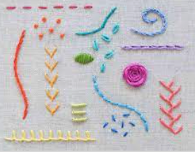

Music
We will continue our Rockband sessions this term. There will be a performance to parents on Friday 12th December.
Geography
This term, we will be learning about volcanoes and earthquakes. We will learn about what causes them and the features of volcanoes. As part of this unit, we will focus on South America and learn about how this continent is affected by earthquakes and volcanoes.

Supporting your child’s learning at home
In term two we would like children to focus on reading at home regularly and recording this in their reading records. We recommend aiming to read at home three times a week. The class teacher will check reading records and stamp them on a weekly basis. Children can also learn the spellings which are published on the website. These will change over a two-week period and will begin in week 1. We would also like children to carry on using times table rockstars to maintain fluency with their times tables.

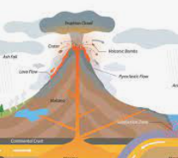
We will be updating our webpage regularly with photographs of what we have been doing, so do check in when you can. We look forward to sharing another great term in Year 5!

Please ensure that your child either comes in their PE kit or brings in to get changed into on their PE days.
PE
This term PE will be: Tag Rugby
PE Days:
5N – Wednesday
5MH – Monday and Friday
5C – Thursday
5B - Friday

French
This term we will be learning about colours, emotions and numbers.

Computing
This term we will be learning about the links between the mars rover and computer aided design.

