Welcome to Term 5
Welcome back to term 5, we are really hoping to enjoy some sunshine and warmer weather over the next few weeks! With only 5 weeks in this term, there is a lot going on, including KS2 SATS! We are looking forward to teaching a range of different activities to engage and interest your children as they head towards the final term of their primary education.

Our curriculum overviews are available on our year page, and you can find details of what we will be learning about in each subject below. If you or anyone that you know has any skills linked to what we will be learning about this term, and you would be willing and able to come in and share them with the children, please let your child’s class teacher know as this can be a very enriching experience for the children and they absolutely love having visitors. We are enjoying welcoming reading volunteers in to read with the children, please let us know if you can help with this.

Please visit our year group web page to find copies of all communication sent home, homework, spellings, key information and dates and photos of us enjoying our learning. We will be available at the end of the school day and can be contacted by email. Our contact details are below and can also be found on the school website, so please do get in contact if you need to at any point.
rherbert@ashtongateprimary.org, cbusby@ashtongateprimary.org, rkenyon@ashtongateprimary.org, rfranklin@ashtongateprimary.org, jhasbrouck@ashtongateprimary.org, kmather@ashtongateprimary.org

Year 6
Term 5
Newsletter

Rising
High
Together




Dates for your diary and special events:
Monday 20th April - First day of Term 5 and Earth Day
Wednesday 29th April – All Together Now Concert at Bristol Beacon
Monday 4th May-Bank holiday
Monday 11th May-Thursday 14th May –Y6 SATs week.
Thursday 14th May – PTA Year 6 Disco
Friday 15th May-End of SATs Y6 breakfast and Non-School Uniform Day
Thursday 21st May – Author Visit
Friday 22nd May –Last day of term
English

Some of our English lessons will be spent revisiting aspects of grammar to support the children in the run-up to SATs. We will
also continue to work at developing our writing and
reading skills ready for Y7. We will be focusing on
developing suspense, using a range of texts and
poems to inspire and interest the children.



As with English, some of our maths lessons will be spent revising different aspects of the subject to support the children in the run-up to SATs. Following this, we will be taking part in a range of investigations which will draw on a number of mathematical skills to support the children as they move towards year 7.


Maths

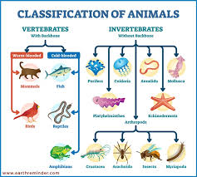
Science

PSHE
This term we will be sharing 5 ways to well-being to support children through SATs and as we begin the process of transition to KS3. We will also be thinking about how we belong and the different groups people might be part of.

In science, we will be looking at living things and their habitats. We will be looking at classifying vertebrates and invertebrates as well as plants.

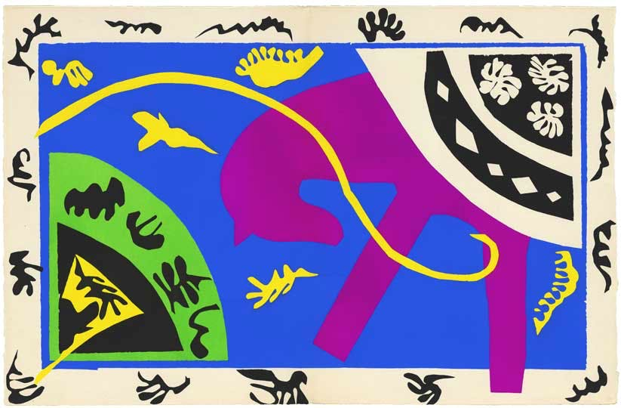
Art
Our final art topic of Y6 is Matisse, building on our work from Y1. We will be beginning this during term 5 and are looking forward to exploring the work of Matisse and –later in the unit-creating our own pieces of art work inspired by what we discover.

Music
We will be beginning our new unit on Samba music in term 5. We will start by listening to and exploring the different rhythms in this music
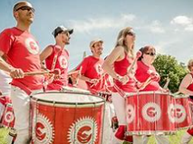
Secondary School visits

We also start the process of transition this term. At the moment, we do not have any dates for when staff from the range of secondary schools will visit, but will update the Y6 webpage when we do.

PE
This term, PE will be: cricket

Week 1
6K Wednesday
6FH Thursday
6BH Thursday
6M Thursday
Year 6 SATs take place this term during the week beginning Monday 11th May. The children have been working very hard this year to ensure they have the knowledge and skills required to do their best in these tests and to prepare for secondary school. You should have all received a letter containing more details about this last term, but please do ask if you need further clarification. A copy of the letter can also be found on the Y6 page.

We will be updating our webpage regularly with photographs of what we have been doing, so do check in when you can. We look forward to sharing a great Term 5 in Year 6!

Supporting your child’s learning at home

Because of SATs week, homework will only be set for the first three weeks of Term 5. This will be sent home during the first week and be available on the Y6 page. As always, we would like all children to spend some time each day reading for pleasure, which they should record in their reading diaries.

m
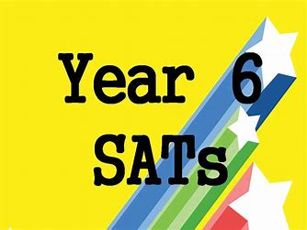

Week 2
6K Friday
6FH Tuesday
6BH Tuesday
6M Thursday


Please ensure that your child wears their PE kit on PE days.

