Welcome to Term 6
Welcome back to the final term of year 6! This year has flown past and we can’t quite believe that we have arrived at the last weeks of your child’s primary education! We hope you have had a lovely half-term and enjoyed the time with family and friends. We wanted to re-iterate how proud we were of Y6 and their positive attitude towards SATs last term; they were fantastic. As you are aware, the tests are externally marked and we expect to have the results back in time for the reports to be emailed to you. We have another jam-packed term coming up, preparing your child for year 7, so please make a note of the dates in the newsletter and on the separate letters that have been sent out to each class.

Our curriculum overview is available on our year page on the website, and you can find details of what we will be learning about in each subject below. Please visit our year group web page to find copies of all communication sent home, homework, spellings, key information and dates and of course, photos of us enjoying our learning. We will be available outside the side door at the end of the school day and can be contacted by email. Our details are below and can also be found on the school website, so please do get in contact if you need to at any point. We are looking forward to a great final term with your children.
rherbert@ashtongateprimary.org, cbusby@ashtongateprimary.org, rkenyon@ashtongateprimary.org, rfranklin@ashtongateprimary.org, jhasbrouck@ashtongateprimary.org, kmather@ashtongateprimary.org

Year 6
Term 6
Newsletter

Rising
High
Together


Dates for your diary
16th June – Class Photos
25th June – Sports Day
26th June – Boat Building (6M)
29th June – INSET Day
30th June – Boat Building (6FH)
1st July – Secondary Transition Day for majority.
2nd July - Ashton Gate Stadium Trip (6FH & 6M)
2nd July - Boat Building (6BH)
3rd July - Boat Building (6K)
6th – 8th July CAMP – 6K & 6FH
8th – 10th July CAMP – 6BH & 6M
15th July – Leavers Disco 7 – 9pm
17th July – End of Year Picnic
21st July – Leavers Assembly (2-3pm)
22nd July - INSET day

English

In our English lessons, we begin by writing some non-fiction texts related to our science and history units. We will also look at some suspense writing; we will
discuss the different features and how they make the
reader feel, before trying some of them out in our own
story openings and descriptions to make our readers feel
uneasy!



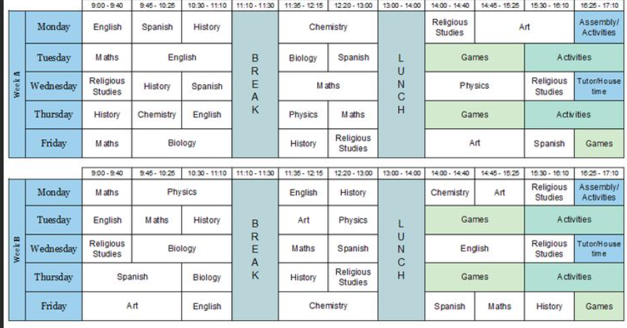
In Maths, we will continue to develop all mathematical skills to help our Y6 children feel ready for their secondary transfer. We will be further developing our investigational skills, as well as learning to read bus and school timetables to support their transition and allowing them to practise and refine their arithmetic and money skills.

Maths

End of Year Assembly
We would like to invite you to share in the Y6 Leavers’ assembly. This will take place in the Upton Hall on Tuesday 21st July at 2pm. Please come and join us as we say farewell to this lovely lot! Due to space restrictions, we have to limit this to 2 people per child. We will also be taking photographs of Y6 ringing Sue Willson’s memorial bell to mark the end of their journey through Ashton Gate, which is always a very poignant moment.

Our science unit this term is Evolution and inheritance. We will explore how life has evolved over time and how living things have changed. We will learn about DNA and what is does. We will examine whether all offspring are identical to their parents. We will learn about Darwin and Wallace and the evidence that they shared when arguing the case for evolution.

Science


Art
We are continuing to study Matisse this term and will be creating some still-life pictures based on his style of painting and our colour studies in term 5. Following this, we will explore Matisse’s collage style of cut-out art to create a final piece.

PSHE
Our PSHE unit this term is all about transitions and their feelings about moving to secondary school.

Secondary School visits

We also start the process of transition this term. Different secondary schools have different transition dates but the Ashton Park Induction day is on Wednesday 1st July.

Geography

In Geography, we will be looking at maps and planning routes, using keys and symbols with a visitor on 24th June. We will also look at directional language and explore our ideas of a sense of place, based on Bristol. Our project homework will be based on this topic and will be sent home and explained to your children. It can also be located on the website.

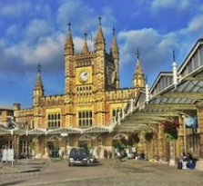


Please ensure that your child wears their PE kit on PE days.
Your child’s class teacher will send a message to each class about the PE dates for each week.

PE
This term, PE will be: Athletics

Religion and Worldviews
We are continuing to explore the question: Why is their suffering? We will look at what suffering can teach us about happiness and learn about the 4 noble truths that can help Buddhists to respond to suffering.

We will be updating our webpage regularly with photographs of what we have been doing, so do check in when you can. We look forward to sharing a great Term 6 in Year 6!

