Ashton Gate Primary School
eSafety tips for parents

What can I do right now?
- Create a family agreement to establish your children’s boundaries and your expectations whilst on the internet.
- Maintain an open dialogue with your child and encourage them to talk about their internet use e.g. who they are talking to, services they are using and any worries they may have.
- Show an interest in the games that they play.
- Give your child strategies to deal with any on-line content that they are not comfortable with – such as turning off the screen, telling an adult they trust and using online reporting facilities.
- Encourage children to use the internet and gaming consoles, within a shared family environment.
- If your child is being bullied online, save all available evidence and report the incident e.g. the school, service provider or police.
- Encourage your children to use nicknames instead of their full name online.
- Set up a family email address when signing up to a new game and websites.
- Read signs – are they upset after using the internet or mobile phone?
- Use safety tools – stop. Block. Tell. message
- ‘ignore’ buttons / privacy settings.
- Check the ‘History’ on the internet
- Never reply to any attacks made.
- Contact the service provider for security measures.
- Keep evidence
- Report

How do I report an incident?
- On site – report button on every site (apparently)
- Let school know
- For any indecent/racist content online contact Internet watch who will remove this
- If you are suspicious of child exploitation / grooming contact the police branch CEOP – Child Exploitation and Online Protection Centre www.ceop.police.uk www.saferinternet.org.uk
- If in immediate danger call 999
- UK Safer Internet Centre Parentport is home to the UK’s media regulators and contains details on how to report, a range of online content, including advertising and games, that you feel may be unsuitable for children. www.parentport.org.uk




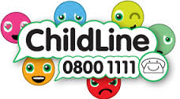

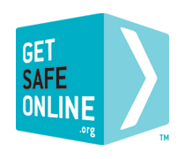
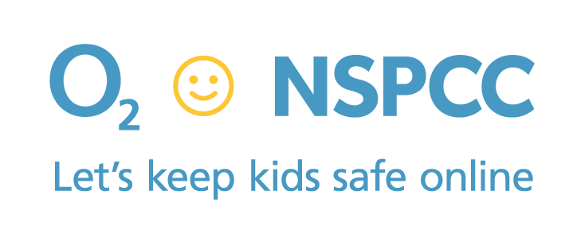



http://www.internetmatters.org/controls/interactive-guide/
https://www.parentport.org.uk/
http://www.childnet.com/resources
https://www.ceop.police.uk/
Where do we go for more information?
https://www.getsafeonline.org/
https://www.nspcc.org.uk/preventing-abuse/keeping-children-safe/online-safety/
http://www.thinkuknow.co.uk/
http://www.childnet.com/resources
http://www.net-aware.org.uk/
http://www.kidsmart.org.uk/

